Class: _______ Number: ________ Name: _________________
- Look, Read, and Ask.
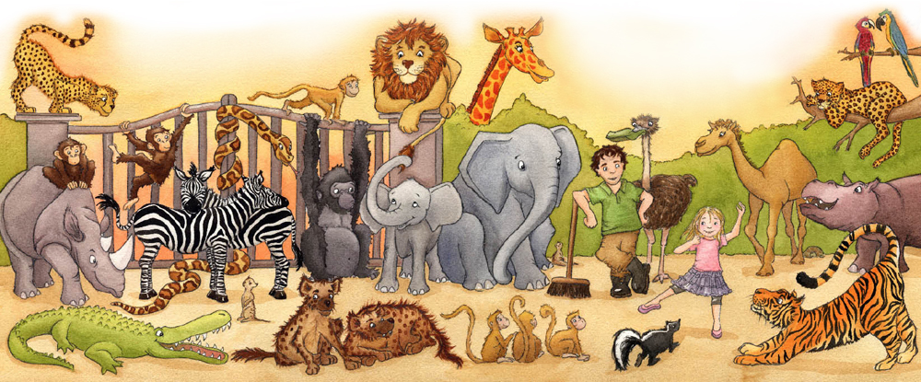
Annie, Bob, Candy, and Danny are going to the zoo. They are happy because(因為) they can see many(許多) animals(動物). There are tigers, lions, zebras, monkeys, and elephants in the zoo. They like animals very much. Do you like animals? What animals do you like?

Your Friend: ________________
 | Questions(問題) | Answers(回答)
1. | Do you see monkeys? | Yes, I do. I see _____________.
2. | How many monkeys are there? | There are __________ _____________.
3. | What do you like? | I like _________________.
4. | How many __________ are there? | There are __________ _____________.
Numbers: one, two, three, four, five, six, seven, eight, nine, ten
- Tell Me What Animals Your Friend Likes
My friend, ___________, likes __________________.
There is ___________ ___________ in the zoo. (兩句擇一)
There are ____________ ______________ in the zoo.
Class: _______ Number: ________ Name: _________________
- Look, Read, and Ask.
Annie, Bob, Candy, and Danny are going to the zoo. They are happy because(因為) they can see many(許多) animals(動物). There are tigers, lions, zebras, monkeys, and elephants in the zoo. They like animals very much. Do you like animals? What animals do you like?

Your Friend: ________________
 | Questions(問題) | Answers(回答)
1. | Do you see elephants? | Yes, I do. I see _____________.
2. | How many elephants are there? | There are __________ _____________.
3. | What do you like? | I like _________________.
4. | How many __________ are there? | There are __________ _____________.
Numbers: one, two, three, four, five, six, seven, eight, nine, ten
- Tell Me What Animals Your Friend Likes
My friend, ___________, likes __________________.
There is ___________ ___________ in the zoo. (兩句擇一)
There are ____________ ______________ in the zoo.

