國民教育輔導團英語輔導小組到校訪視
平興國民小學106學年度第2學期語文學習領域英語科教學設計
活動名稱 | 輔導團到校輔導 |  | 單元名稱 | Where are you going?
科 目 | English |  | 教材來源 | Give Me Five 6, Unit 4
設 計 者 | 詹淳涵 |  | 教學對象 | Grade 5, Class 3
教學時數 | 40 minutes |  | 演示節次 | The first period of six periods
學習目標 |  |  | 分段能力指標
- Learning places in town.  - Conversing with sentence patterns:  Q: Where ___ ___going?  A: _____ going to the _____. |  |  | I3-1 能聽懂、讀懂、說出並寫出 高年段所習得的 詞彙。  I3-3 能聽懂、讀懂、並說出或抄 寫高年段所習得的句子。  I3-4 能活用字母拼讀法。  S3-6 能以高年段簡易句型作適當 的提問、回答。  A3 對於教師的說明與演示，能集中注意力。  A13 能認真完成教師交待的作業。
教材內容分析 |  |  | 學生能力/背景分析
Grammar:  - Information question with where  Where are you going?  I am going to the bookstore.  - Comparing demonstrative pronouns and be verbs  I am / we are / you are / they are /he is /  she is  Vocabulary:  bakery, bookstore, hospital, library, supermarket, tea shop |  |  | Students previously learned:  Grammar:  - Information question with where  Where are you?  I am at the park.  - Comparing demonstrative pronouns and be verbs  I am / we are / you are / they are /he is /  she is  Vocabulary:  home, school, park, zoo
課程設計理念
According to Stephen Krashen's “i+1” theory of second language acquisition, if a learner is at a stage 'i', then acquisition takes place when he/she is exposed to 'Comprehensible Input' that belongs to level 'i + 1'. This lesson plan applies the “i+1” theory and constructs a step by step process to help students learn. Besides, Lots of pictures are used to make input more comprehensible.
教學活動 |  |  |  |  | 教學資源 | 教學時間 | 評量方式
Teacher’s Task |  | Students’ Task |  |  | 教學資源 | 教學時間 | 評量方式
- Warm up  Review  - Greet the class and ask students:  Where are you now?  - Project p.40 of the textbook ( Appendix i ) on the screen. Point to different places of the picture in turns and ask the question: Where are you?  - Project p.41 ( Appendix ii ) on the screen. Ask questions such as: Where is Annie/ Bob?  - Presentation  Vocabulary of places  - Project p.45 ( Appendix iii ) on the screen. Drill the vocabulary and have students repeat.  - Explain the vocabulary in detail (syllables, etymology, and compound words) using pptA (appendix iv).  - Use pptB to show the pictures of the neighborhood places. Elicit students to say the vocabulary of those pictures together.  Introduce New Patterns  - Introduce the new patterns.  Where are you going?  I’m going to the bakery.  Play pptB and ask students:  Where are you going?  - Direct students’ attention to the grammar boxes on page 46 ( Appendix v ). Ask students to read the grammar boxes together.  - Teacher asks questions with pptC:  Where is he/ are Bob and Danny going?  - Practice  Pair Work  3.1With the below picture on p.46, student pairs ask and answer questions using the language on this page. The subject and place have to be changed.  3.2Call two students and ask them to practice saying this pattern with subject and place set by Teacher. Then this pair calls two other students to continue this exchange.  Write and Say  3.3Work on the bottom of p.46. Teacher asks:  If you plan to buy some books, where are you going?  If she plans to buy a cup of tea, where is she going?  - Direct students to fill in the blank of Write and Say part on p.46.  - Check the answer by asking:  One, Where is Doc going?  - Production  Ask students to act out or give the clue of the vocabulary in turn. Teacher asks the others: Where is he/ she going?  If time is enough, the vocabulary of the previous unit (kitchen, bathroom , living room…) can be linked.  - Wrap up  Use the projector to instruct students to write worksheet A (appendix vi).  Call student pairs to present their answer. |  | Students answer:  We are at school.  Students answer together according to the picture that Teacher points to:  We are at the park.  Students answer together:  She/ He is at the zoo/ at home.  Students practice under the direction of Teacher.  Students are encouraged to guess the syllables.  Students say the vocabulary according to the pictures on the screen.  Students say the sentence according to the picture on screen.  Students point fingers while reading the sentences in the grammar boxes.  Students answer:  He is/ They are going to the bakery.  Students practice dialogue:  A: Where is she going?  B: She is going to the park.  A: Where are you going?  B:We are going to the bakery.  Students answer: I am going to the bookstore. and hold up their little  picture cards.  Students answer: She is going to the tea shop. and hold up their little picture cards.  Students write the numbers on the blanks.  Students answer: He is going to the bookstore.  One student gives the clue, the other students who know the answer raise their hands. The one whose name is called answers: He/ She is going to the supermarket.  Students write Worksheet A.  Student pairs stand up and practice dialogue using the language in the worksheet, and switch roles. |  |  | E-book,  Projector  E-book  projector  pptA  pptB  pptC  E-book  projector  projector,  Worksheet A | 3 min  15  min  12  min  5  min  5 min | Students can use the language learned before.  Students can say it loudly.  Students can pay their attention.  Students can say the words correctly.  Students can say the sentences correctly.  Students can do as Teacher directs.  Students can say the sentences correctly.  Students can participate in the pair work.  Students can say the sentences correctly.  Students can answer correctly and hold up the correct cards.  Students write the correct answers.  Students can participate in the activity.  Students can write and say correctly.

Appendix i
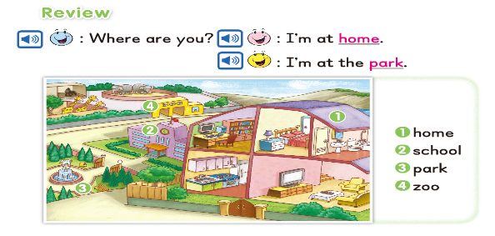

Appendix ii
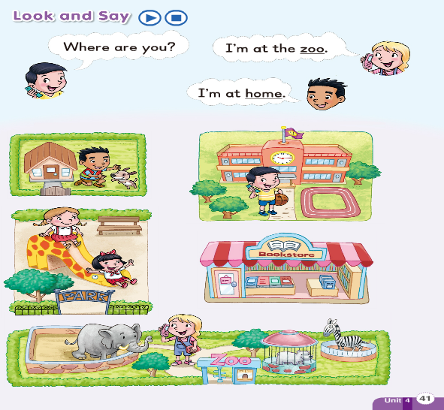

Appendix iii

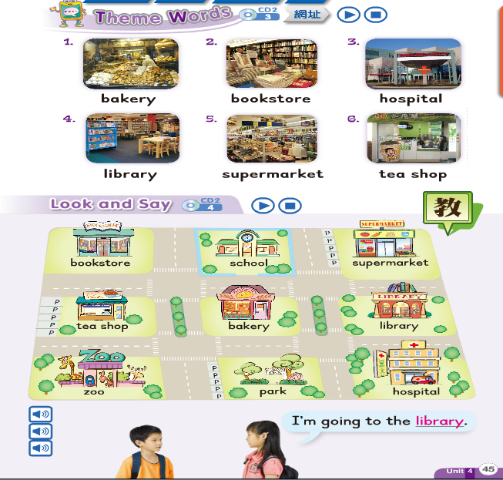

Appendix iv
(ppt)
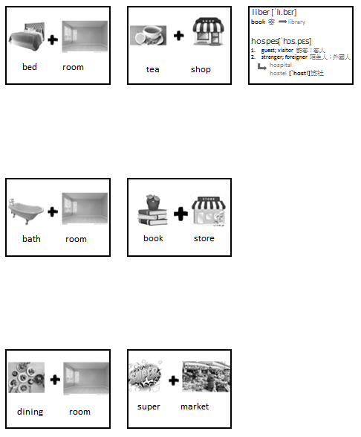

Appendix v
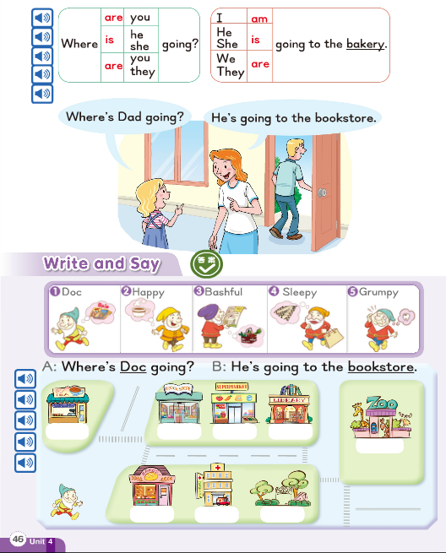

Appendix vi

Class_____________ Number_____________ Name_________________________
- bird  - bath  - basket  - rain  - bed  - book  - cup  - super | - coat  - bath  - ball  - cake  - market  - store  - room | 1 + b = birdbath   2  3  4  5  6  7  8

- Where are you going?
I am going to the bookstore.

- Where are Bob and you going?

- Where are Bob and Candy going?

- Where is Annie going?

- Where is Danny going?

