素養導向課程教案格式
領域/科目 |  | 英語 | 設計者 |  |  | 白芸禎
實施年級 |  | 四 | 總節數 |  |  | 共 6 節，240 分鐘
單元名稱 |  | Unit 2 What are you doing?
學生分析 |  | 25名，7組，異質性分組，無特殊生。
教材分析 |  | 康軒 Follow me 4 Unit 2
設計依據
學習  重點 | 學習  表現 | - 1-Ⅱ-10 能聽懂簡易句型的句子  - 3-Ⅱ-3能看懂課堂中所學的句子  - 4-Ⅱ-4 能臨摹抄寫課堂中所學的句子  - 5-Ⅱ-3 能以正確的發音及適切的速度朗讀簡易句型的句子。  - 6-Ⅱ-1 能專注於教師的說明與演示 |  | 核心  素養 | - 英-E-B1  具備入門的聽、說、讀、寫英語文能力。在引導下，能運用所學、字詞及句型進行簡易日常溝通。  - 英-E-C2  積極參與課內英語文小組學習活動、培養團隊合作精神。
學習  重點 | 學習  內容 | - Ac-II-2簡易的生活用語  - B-II-1 第二階段所學字詞及句型的生活溝通 |  | 核心  素養
教材來源 |  | 康軒 Follow me 4 Unit 2
教學設備/資源 |  | flash cards, wordcards, worksheets
學習目標
- 學生能熟練句型I'm V-ing in (place) . He / She is V-ing in (place) . 並依提示完成學習單。

教學活動設計
學習目標 | 教學活動內容及實施方式 | 教具 | 時間 | 評量方式
5-Ⅱ-3  6-Ⅱ-1  1-Ⅱ-10  3-Ⅱ-3  5-Ⅱ-3  4-Ⅱ-4 | Warm up (listen, read and say)  - Play the music on p.30  - Read the lyrics.  - Sing together  Presentation (read and say)  - According to the lyrics, "She's singing in the bathroom." Raise Ss' awareness of telling 2 pieces of information in one sentence. (use "in" to add places)  - Practice reading sentences on the board by changing the places' flash cards and V-ing flash cards.  Practice  Guess who’s the leader? (listen and say)  Practice sentence pattern.  - Pick S1 to be “it” and wait outside.  - Pick S2 to be the leader.  - S1 should ask the Q on the blackboard  - The whole class has to answer A1 while S2, the leader, is answering A2  - S1 has to guess who the leader is(S2)  Calculated sentences (read and say)  Practice to say the target sentence according to sentence pattern that just practiced.  - Each group will have 2 piles of cards. Ss shuffle the cards facing down.  - S1 picks one card from each pile saying "I'm cooking in the dining room." if the cards are "cooking" and "dining room", then show the 2 cards.  - S2 also picks 2 cards but S2 has to repeat the sentence by changing the subject that S1 said first. For example, "He’s / She's cooking in the dining room. I'm studying in the kitchen." in order to  - Each team has to finish 4 rounds with different beginners. The first three teams can win 3 points for their groups.  Production  Information gap (S/L/W)  Produce sentences in writing.  - Pick 2 cards and produce the sentence writing on their own worksheets.  - They have to ask team mates to get information of who is doing what in which room.  - Ss write down sentences and draw the person in the correct room.  - Check the spellings. (everyone has different answers)  Wrap up  Assign homework. | Music  Flash  cards  Flash  cards  Word  cards  Word  cards  Work  sheets | 3"  5"  6"  10"  15"  1" | 課堂觀察  活動評量  活動評量  小組評量  紙筆評量

L 2What are you doing? class: number: name:
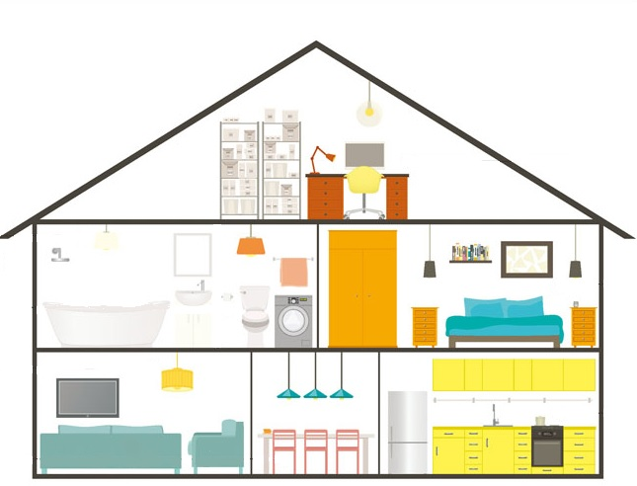
Fill in the blanks. Draw your classmates in rooms. Make a new sentence and draw a new room.

Q: What are you doing?


A: I am in the .

Q: What is doing?

A: He’s .

Q: What is doing?


A: She’s .


Q:

A:
What are you doing? class: number: name:
Fill in the blanks. Draw your classmates in rooms. Make a new sentence and draw a new room.(slow learners' ver.)

Q: What are you doing?

A: I am in the .

Q: What is doing?

A: He’s in the .
bathroom
bedroom

Q: What is doing?


A: She's in the .
kitchen
dining
room
living room

Q: What is doing?

A: .

