Worksheet(學習單)
class: name:
Directions: Glue the Absolute and Relative location definitions at the front page.
Read the following examples and decide if they tell an Absolute or Relative location. Place them on the correct place and come verify with me if they are correct you glue them in.
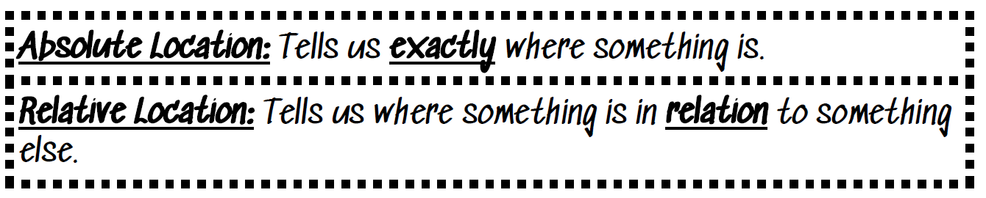
Absolute location | Relative location

326 Yanping Road, Taoyuan District, Taoyuan City  桃園市桃園區延平路326號 | Mrs. Miller’s classroom is next door to Mr. Frank’s classroom.
Taoyuan is located south of Taipei. | Nairobi, Kenya is at 1.29° S, 36.8°E.
The store I need to go to is right next door to 全聯. | The library is right outside of Chiang Kai-shek Memorial Hall.
Emily’s class is in room 818 at the end of the 2nd floor of the school. | Taiwan is 23 degrees north and 120 degrees east.

