Topic three: Postcrossing-01 Class: Number: Name:
Introduction
Because of the outbreak of Covid-19, it’s not easy for us to take a trip. However, we still have a chance to interact with the real world. Let’s postcross. Let’s go.
Read the postcard and answer the questions
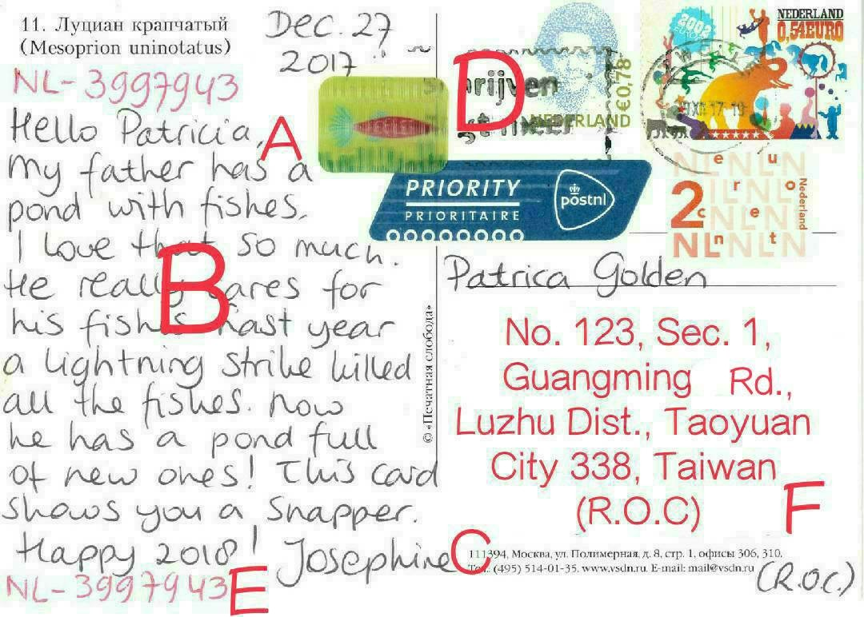
__A__ recipient
_____ body
_____ signature/ sender
_____ stamp
_____ postcard ID
_____ address
_____ others: _________
_____ others: _________
Fill in the blanks
英文 | 縮寫 | 中文 | 英文 | 縮寫 | 中文
District | Dist. | 區 | Village | Vil. | 村（里）
Street | St. | 街 | Boulevard | Blvd. | 大道
Section | Sec. | 段 | Lane | Ln. | 巷
Alley | Aly. | 弄 | Number | No. | 號
Floor | F | 樓 | Room | Rm. | 室

Google it
GMJH: No. 123, Sec. 1, Guangming Rd., Luzhu Dist., Taoyuan City 338, Taiwan (R.O.C.)
How about your home address?
__________________________________________________________________________
Write your own and say it
Hello, everyone, my name is ________. I am a student from GMJH. My school/ home(circle) address is _________________________________________________. Please send me a postcard. 01
Topic three: Postcrossing-02 Class: Number: Name:
Review time
Q and A activity to earn some cards for your group!
Useful words to log in Postcross website
English | sign up | log in | profile | gender | sign out
Chinese | 註冊 | 登入 | 個人檔案 | 性別 | 登出
Homework: Apply your own account and give it a shot.
How to select a postcard theme?
- Use your drawing to introduce Taiwan. What are Taiwan’s features?
- Use your drawing to introduce 7 continents and the world. What are their features?
- What do you want to share? Draw your hobbies, things you like, or something about the body.
How many kinds of postcards are there?
multi- view cards | focus on one thing | focus on one topic | landscape | shaped cards | drawings
 | 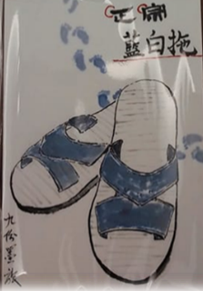 | 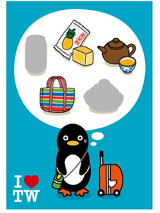 | 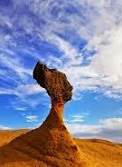 | 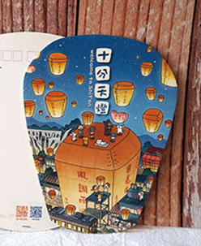 | 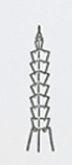
Write your own and say it

Profile- mine 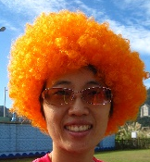
My name is Patricia. I am an English teacher from Guang Ming Junior High School. I come from Taiwan. I am going to have a trip in Africa. Please send me a postcard about her. Happy Postcrossing!

Profile- yours
My name is ________. I am ___________ from Guang Ming Junior High School. I come from ________. I am going to have a trip in ____________. Please send me a postcard about her. Happy Postcrossing!
Class:____ Number:____ Name:________
02

Draw your own postcard.



