Learning with Picture Books
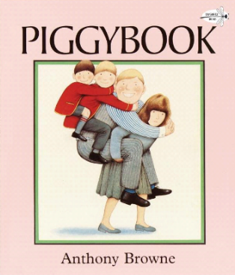
109-2 EGRC E-Maker
7th graders Name
DEADLINE: 2021/4/30
20
Piggybook by Anthony Browne I

A. Pre-reading/listening: APP--Mentimeter

1. Look at the cover, what do you see? 2. Predict-what is the story about?
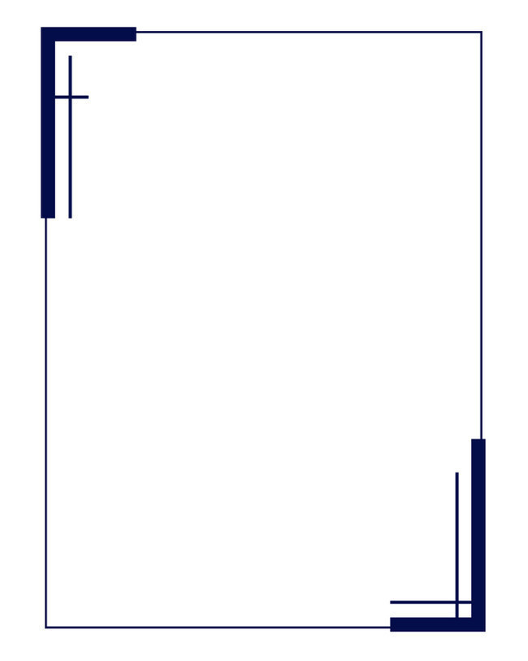

2. What is a word cloud(文字雲)?
1. A word cloud is a image of text data or a topic, used to show .
2. Tags are usually or .
The words are in different according to
or they are in the text.
3. Word clouds can be in any that you like.

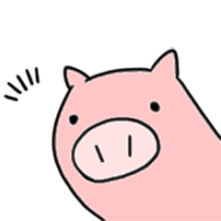

B. While-reading
Part I Comprehension Check (in class)
1. What kinds of house chores are mentioned in the story?

2. Why does the writer repeat the word “important”?

3. Why does Mom leave the house?

Part II Comprehension Check (after school)
1. Write down the words used to describe pigs in this story.

2. How is Mrs. Piggott’s face different from those of Mr. Piggott and boys?

3. Piggy Hunt
a. Why do you think pigs were hidden throughout the story?
b. Why do you think there are more pigs hidden as the story goes on?

C. After-reading
Part I Marker Talk(色筆談話)--Write down your thoughts beforehand (after school)
1. What is the message of this story?

2. Mom is fixing the car at the end of the story. What may it suggest?

3. If you were Mom, would you be willing to do the same chores every day?
What would you do to improve the situation?


PHOTO HERE!

Part II—Word Cloud Creation
1. After our thorough discussion of Piggybook, please create a word cloud with iPad to show your understanding of this picture book.
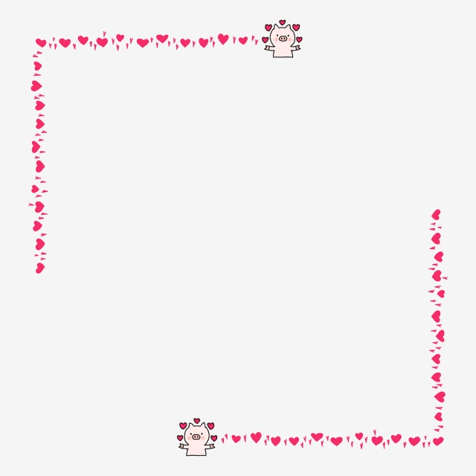
2. 這學期截至目前，我們上了兩本繪本，從繪本閱讀歷程中，你的感受是?
你學到甚麼?最喜歡哪個部份?有遇上哪些困難嗎?你運用了哪些策略?



