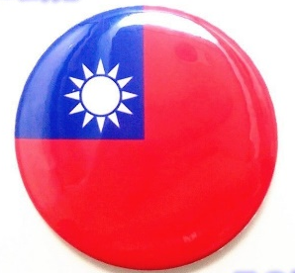
U1 The Steak Looks Yummy─Dialogue Worksheet
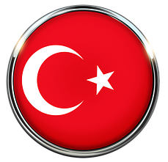
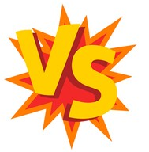

Part 1 Dialogue Q&A
@ Circle the correct answer
1.Taiwan is ( bigger / smaller ) than Turkey
2. Taiwan is ( warmer / colder ) than Turkey.
3. Getting around in Taiwan is ( harder / easier) than in Turkey.
4. Ela and her family ( eat / don’t eat ) beef.
5. Beef dishes in Taiwan is ( better / worse ) than in Turkey.
@ Write down the correct answers
1.What did Zac order? | Ans:
2.How would Ela like her steak? | Ans:
3. Did the girls order pumpkin pie with ice cream? | Ans:


Part 2 Survey─Find the Difference of Taiwan and Turkey
- It ( snows / doesn’t snow ) in Turkey in winter.
- It is about ( two / twenty ) size of Taiwan.
- Most people in Turkey ( like / don’t like ) to put sugar in their tea.
- Most people in Turkey don’t eat pork because____________________

